Rokan Ali Ahmed  Lec.PhD in  Department of Electronic Engineering,  College of Engineering, University of Diyala,  Baqubah, Diyala Province, Iraq  rokan.Ahmed@uodiyala.edu.iq | 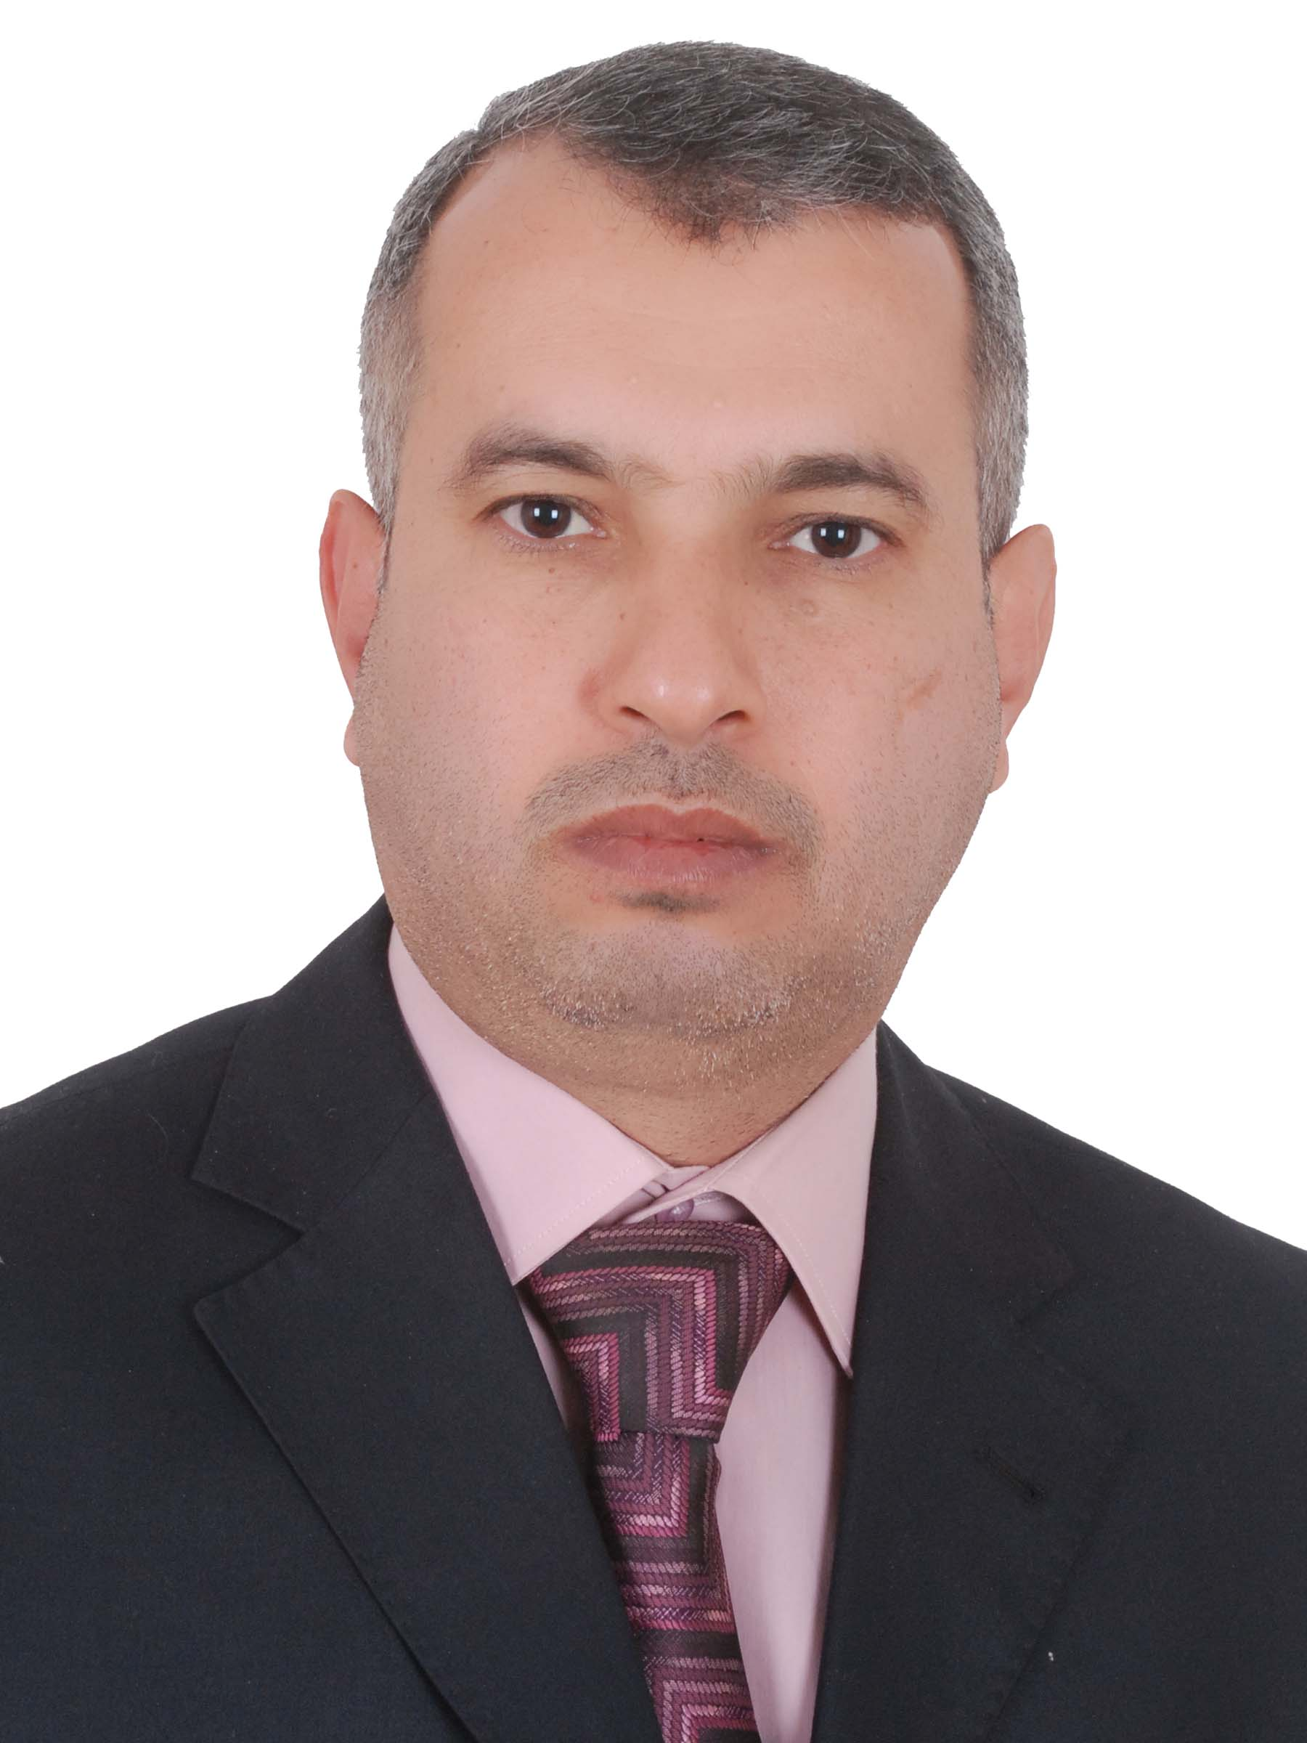
Personal Information
Academic degree: Lecturer
h – Index: 2 calculated by Google Scholar
Birth Date & Place: January, 6, 1970 – Iraq
Nationality: Iraqi
Marital Status: Married
Email: Rokan_l4@yahoo.com and rokan.Ahmed@uodiyala.edu.iq
Website: www.uodiyala.edu.iq
Postal address: Department of Electronic Engineering, College of Engineering, Diyala University, Baquba City, Diyala Governorate, ZIP 32001, Iraq
Professional Strength and Skill
- Very effective in analogue and digital electronic, and power electronic. Also, main interests include the areas of power electronic circuit and power electronic converter for renewable energy sources
- Wide theoretical knowledge in most subject of electrical and electronic engineering such as analog and digital electronics , digital signal processing, control, digital systems design, hardware description language, mathematics, engineering analysis.

Educational Qualifications
- Ph.D. (2013) University of Malaya/ College of Engineering / Electrical Engineering Department / Power Electronics.
- M. Sc. (2001) University of Technology/ AL-Rasheed College of Engineering and Science / Electrical and Electronics Engineering/ Electronics.
- B. Sc. (1994) University of Technology/ AL-Rasheed College of Engineering and Science / Electrical and Electronic Engineering
Memberships and Academic positions
- Member of the Examination Committee, Electronic Engineering Department, College of Engineering, Diyala University since 20016 till now.
- Member of the Scientific Committee, Electronic Engineering Department, College of Engineering, Diyala University since 2014-2016.
- Member of the Examination Committee, Electronic Engineering Department, College of Engineering, Diyala University 2005-2008
- Member of the Scientific Committee, Electronic Engineering Department, College of Engineering, Diyala University 2005-2008
- Coordinator - Electronic Engineering Department, College of Engineering, Diyala University 2005-2007
- Member of Iraqi Engineers Union (IEU).

Training and Courses
- Computer Programming Course for half month in College of Education– Diyala University – Iraq - 2015.
- Methods of Teaching Course for one month in College of Education– Diyala University – Iraq - 2004.
- Several workshops during my PhD study.

Languages
- English: Written and spoken (good)
- Arabic: Mother tongue.

Software and Tools
- PSpice
- Matlab: Simulink
- DSP
- Electronics Workbench
- Multisim
- Quartus II Design Software
- VHDL
- Microsoft Office, Word, Excel, and Power Point

Employment History (Academic & Technical)
Diyala University – College of Engineering (2004 – till now)
Location: Diyala – Iraq
Position: Lecturer in Electronic Engineering Department.
Academic degree: Lecturer
Description: Teaching Electronic I & Electronic II for the second stage and third stage ,and Power Electronics for the fourth stage .
Supervisor for many graduate projects for undergraduate students.
University of Technology/ AL-Rasheed College of Engineering and Science (1994– 2004)
Location: Baghdad – Iraq
Position: Lecturer in Electrical and Electronic Engineering Department
Description: Teaching Electrical Engineering Fundamentals for the first stage, Electronic I for the second stage and Lab Demonstrator (Electronic and Microprocessors Labs).

Publications
- Ahmed, R., Mekhilef, S., & Ping, H. (2012). Asymmetrical multilevel inverter topology with reduced number of switches. International Review of Electrical Engineering, 7(4), 4761-4767.
- Ahmed, R. A., Mekhilef, S., & Ping, H. W. (2010). New multilevel inverter topology with minimum number of switches. Paper presented at the TENCON 2010-2010 IEEE Region 10 Conference.
- Ahmed, R. A., Mekhilef, S., & Ping, H. W. New multilevel inverter topology with reduced number of switches. Paper presented at the MEPCON 2010 ,14th International Middle East Power System Conference Cairo, Egypt, 2010
- . Ahmed, R. A., Mekhilef, S., & Ping, H. W. (2009). A three-phase shunt Active Power Filter with Unified Constant Frequency Integration Control with RLC connection circuit. Paper presented at the Technical Postgraduates (TECHPOS), 2009 International Conference.
- Ahmed, R. A., (2015). New symmetrical multilevel inverter with reduction of switches. Paper presented at the second scientific conference of Engineering sciences. University of Diyala.

More information about my scientific activity can be found via links below:
Google Scholar | https://scholar.google.com/citations?hl=en&user=sCWwG-sAAAAJ
Research Gate | https://www.researchgate.net/profile/Rokan_Ahmed
ORCID ID | https://orcid.org/0000-0001-7654-765X
Publons  | https://publons.com/researcher/1774207/rokan-ahmed

